NAME – Pranjal Pandey
SupersetID – 8001665
Cognizant-Hands-on-Exercises Java FSE

WEEK-1 : DESIGN PATTERNS AND PRINCIPLES

Exercise 1: Implementing the Singleton Pattern
- Logger.java
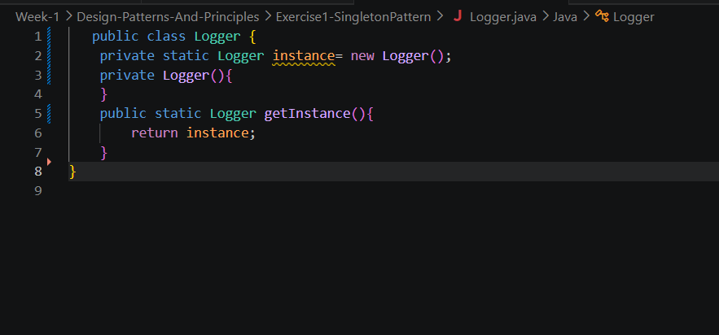
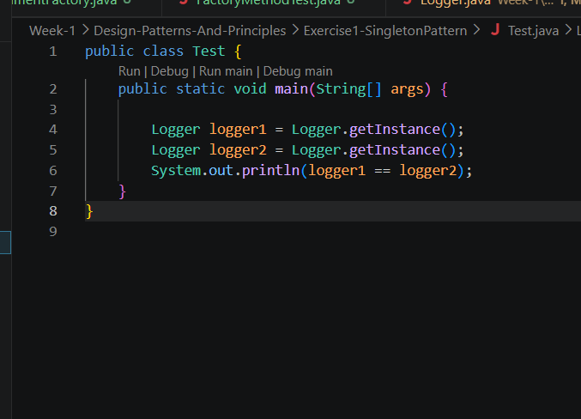
- Test.java

Exercise 2: Implementing the Factory Method Pattern

- Document.java
public abstract class Document {
public abstract void open();
public abstract void save();
public abstract void close();
}

- DocumentFactory.java
public abstract class DocumentFactory {
public abstract Document createDocument();

public void openDocument() {
Document doc = createDocument();
doc.open();
doc.save();
doc.close();
}
}

- ExcelDocument.java

public class ExcelDocument extends Document {
@Override
public void open() { System.out.println("Opening Excel Document (.xlsx)"); }
@Override
public void save() { System.out.println("Saving Excel Document"); }
@Override
public void close() { System.out.println("Closing Excel Document"); }
}

- ExcelDocumentFactory.java
public class ExcelDocumentFactory extends DocumentFactory {
@Override
public Document createDocument() { return new ExcelDocument(); }
}

- FactoryMethodTest.java

public class FactoryMethodTest {
public static void main(String[] args) {
DocumentFactory[] factories = {
new WordDocumentFactory(),
new PdfDocumentFactory(),
new ExcelDocumentFactory()
};

for (DocumentFactory factory : factories) {
factory.openDocument();
System.out.println("---");
}
}
}

- PdfDocument.java

public class FactoryMethodTest {
public static void main(String[] args) {
DocumentFactory[] factories = {
new WordDocumentFactory(),
new PdfDocumentFactory(),
new ExcelDocumentFactory()
};

for (DocumentFactory factory : factories) {
factory.openDocument();
System.out.println("---");
}
}
}

- PdfDocumentFactory.java

public class PdfDocumentFactory extends DocumentFactory {
@Override
public Document createDocument() {
return new PdfDocument();
}
}

- WordDocument.java
public class WordDocument extends Document {
@Override
public void open() { System.out.println("Opening Word Document (.docx)"); }
@Override
public void save() { System.out.println("Saving Word Document"); }
@Override
public void close() { System.out.println("Closing Word Document"); }
}

- WordDocumentFactory.java
public class WordDocumentFactory extends DocumentFactory {
@Override
public Document createDocument() { return new WordDocument(); }
}

Folder Structure:
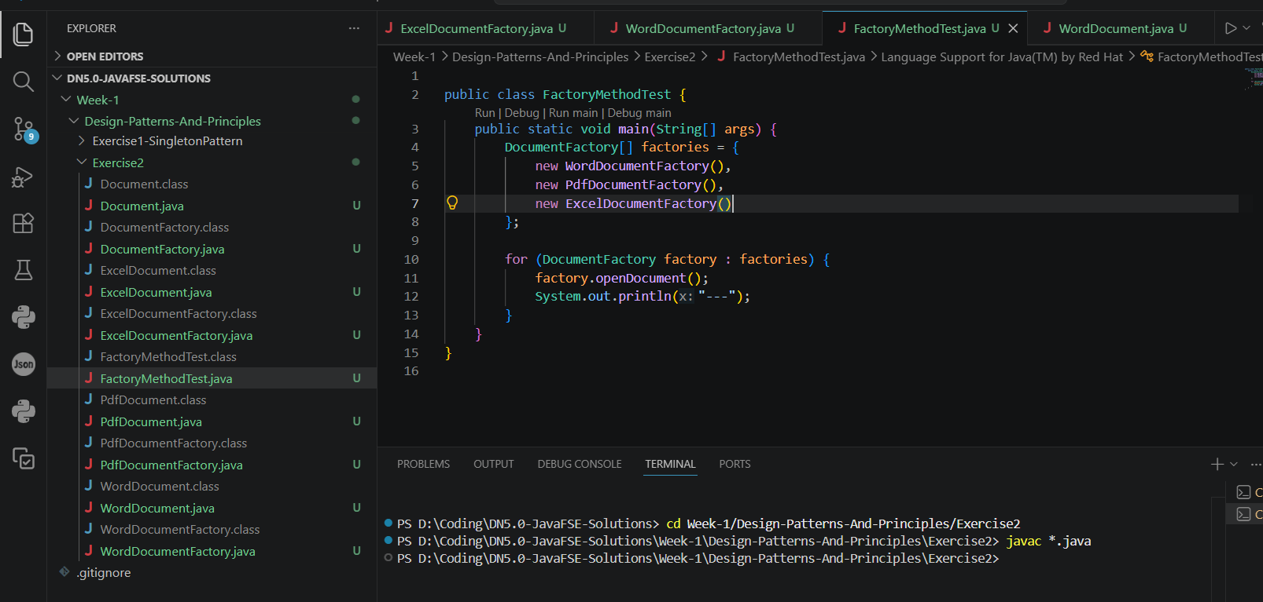

Exercise 3: Implementing the Builder Pattern

- Computer.java
public class Computer {
// Required
private final String cpu;
private final String ram;
// Optional
private final String storage;
private final String gpu;
private final boolean hasWifi;
private final boolean hasBluetooth;

private Computer(Builder builder) {
this.cpu = builder.cpu;
this.ram = builder.ram;
this.storage = builder.storage;
this.gpu = builder.gpu;
this.hasWifi = builder.hasWifi;
this.hasBluetooth = builder.hasBluetooth;
}

@Override
public String toString() {
return "Computer { CPU='" + cpu + "', RAM='" + ram +
"', Storage='" + storage + "', GPU='" + gpu +
"', WiFi=" + hasWifi + ", Bluetooth=" + hasBluetooth + " }";
}

// ── Static nested Builder ──────────────────────────────────
public static class Builder {
private final String cpu;
private final String ram;
private String storage = "256GB SSD";
private String gpu = "Integrated";
private boolean hasWifi = true;
private boolean hasBluetooth = false;

public Builder(String cpu, String ram) {
this.cpu = cpu;
this.ram = ram;
}

public Builder storage(String storage) { this.storage = storage; return this; }
public Builder gpu(String gpu) { this.gpu = gpu; return this; }
public Builder hasWifi(boolean val) { hasWifi = val; return this; }
public Builder hasBluetooth(boolean val) { hasBluetooth = val; return this; }

public Computer build() { return new Computer(this); }
}
}

- BuilderTest.java
public class BuilderTest {
public static void main(String[] args) {
Computer gaming = new Computer.Builder("Intel i9", "32GB")
.storage("2TB NVMe SSD")
.gpu("NVIDIA RTX 4080")
.hasWifi(true)
.hasBluetooth(true)
.build();

Computer office = new Computer.Builder("Intel i5", "8GB")
.storage("512GB SSD")
.build();

System.out.println("Gaming PC : " + gaming);
System.out.println("Office PC : " + office);
}
}

Folder Structure:
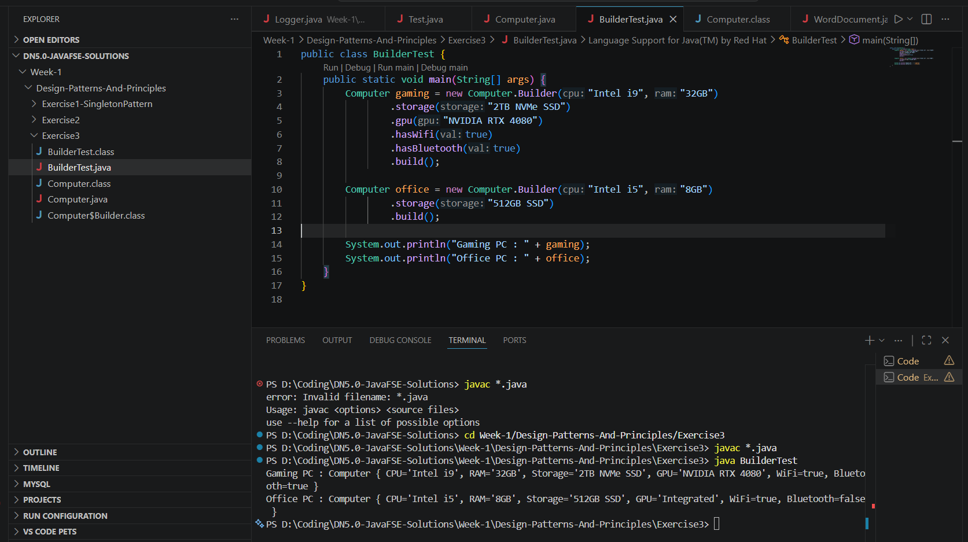

Exercise 4: Implementing the Adapter Pattern

- PaymentProcessor.java
public interface PaymentProcessor {
void processPayment(double amount);
}

- PayPalGateway.java
public class PayPalGateway {
public void makePayment(double amount) {
System.out.println("PayPal: Processing $" + amount);
}
}

- StripeGateway.java
public class StripeGateway {
public void charge(String currency, double amount) {
System.out.println("Stripe: Charging " + currency + " " + amount);
}
}

- PayPalAdapter.java

public class PayPalAdapter implements PaymentProcessor {
private final PayPalGateway payPal;

public PayPalAdapter(PayPalGateway payPal) { this.payPal = payPal; }

@Override
public void processPayment(double amount) {
payPal.makePayment(amount); // translate call
}
}

- StripeAdaptor.java
public class StripeAdapter implements PaymentProcessor {
private final StripeGateway stripe;

public StripeAdapter(StripeGateway stripe) { this.stripe = stripe; }

@Override
public void processPayment(double amount) {
stripe.charge("USD", amount);
}
}

- AdapterTest.java
public class AdapterTest {
public static void main(String[] args) {
PaymentProcessor paypal = new PayPalAdapter(new PayPalGateway());
PaymentProcessor stripe = new StripeAdapter(new StripeGateway());

paypal.processPayment(150.00);
stripe.processPayment(250.00);
}
}

Folder Structure:
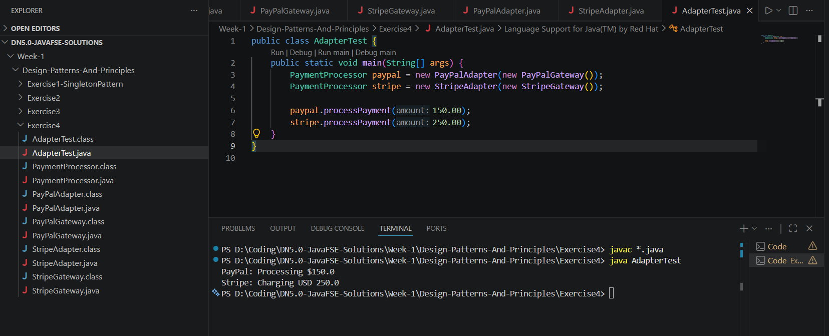

Exercise 5: Implementing the Decorator Pattern
- Notifier.java
public interface Notifier {
void send(String message);
}
- EmailNotifier.java
public class EmailNotifier implements Notifier {
@Override
public void send(String message) {
System.out.println("[Email] Sending: " + message);
}
}

- NotifierDecorator.java
public abstract class NotifierDecorator implements Notifier {
protected final Notifier wrapped;

public NotifierDecorator(Notifier wrapped) { this.wrapped = wrapped; }

@Override
public void send(String message) { wrapped.send(message); }
}

- SMSNotifierDecorator.java
public class SMSNotifierDecorator extends NotifierDecorator {
public SMSNotifierDecorator(Notifier wrapped) { super(wrapped); }

@Override
public void send(String message) {
super.send(message);
System.out.println("[SMS] Sending: " + message);
}
}

- SlackNotifierDecorator.java
public class SlackNotifierDecorator extends NotifierDecorator {
public SlackNotifierDecorator(Notifier wrapped) { super(wrapped); }

@Override
public void send(String message) {
super.send(message);
System.out.println("[Slack] Sending: " + message);
}
}

- DecoratorTest.java
public class DecoratorTest {
public static void main(String[] args) {
// Email only
Notifier emailOnly = new EmailNotifier();
emailOnly.send("Hello!");
System.out.println("---");

// Email + SMS
Notifier emailSms = new SMSNotifierDecorator(new EmailNotifier());
emailSms.send("Alert!");
System.out.println("---");

// Email + SMS + Slack
Notifier all = new SlackNotifierDecorator(
new SMSNotifierDecorator(
new EmailNotifier()));
all.send("Critical Update!");
}
}

Folder Structure:
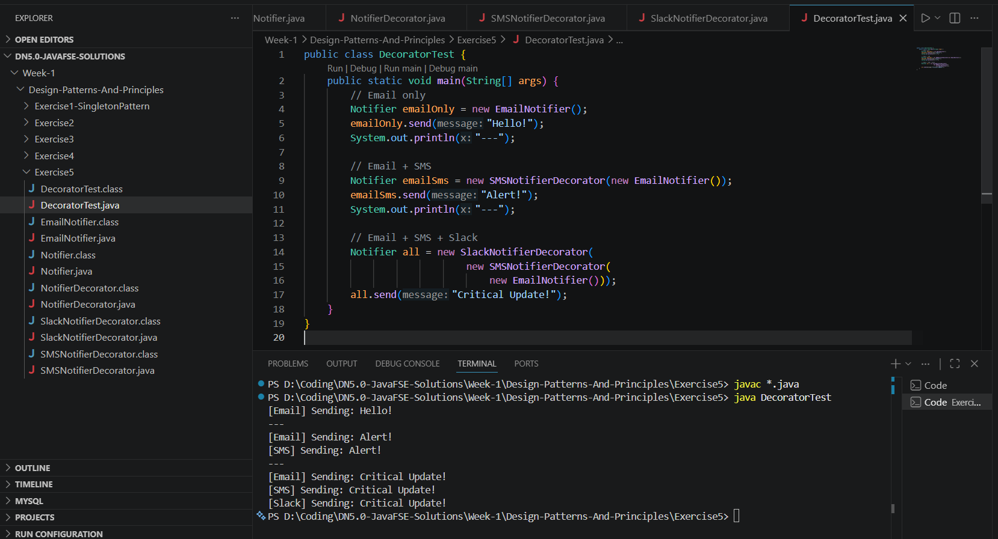

Exercise 6: Implementing the Proxy Pattern

- Image.java
public interface Image {
void display();
}

- RealImage.java
public class RealImage implements Image {
private final String filename;

public RealImage(String filename) {
this.filename = filename;
loadFromServer();
}

private void loadFromServer() {
System.out.println("Loading image from remote server: " + filename);
}

@Override
public void display() {
System.out.println("Displaying: " + filename);
}
}

- ProxyImage.java
public class ProxyImage implements Image {
private final String filename;
private RealImage cachedImage; // cache

public ProxyImage(String filename) { this.filename = filename; }

@Override
public void display() {
if (cachedImage == null) {
System.out.println("[Proxy] Cache miss – loading...");
cachedImage = new RealImage(filename); // lazy init
} else {
System.out.println("[Proxy] Serving from cache.");
}
cachedImage.display();
}
}

- ProxyTest.java
public class ProxyTest {
public static void main(String[] args) {
Image img = new ProxyImage("photo.jpg");

img.display(); // loads from server
System.out.println();
img.display(); // served from cache
}
}

Folder Structure:
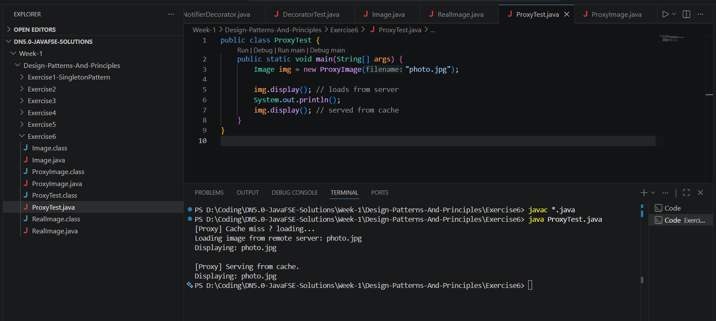

Exercise 7: Implementing the Observer Pattern
- Observer.java
public interface Observer {
void update(String stockName, double price);
}

- Stock.java
public interface Stock {
void register(Observer o);
void deregister(Observer o);
void notifyObservers();
}

- StockMarket.java
import java.util.ArrayList;
import java.util.List;

public class StockMarket implements Stock {
private final List<Observer> observers = new ArrayList<>();
private String stockName;
private double price;

public void setStockPrice(String name, double price) {
this.stockName = name;
this.price = price;
notifyObservers();
}

@Override public void register(Observer o) { observers.add(o); }
@Override public void deregister(Observer o) { observers.remove(o); }

@Override
public void notifyObservers() {
for (Observer o : observers) o.update(stockName, price);
}
}

- MobileApp.java
public class MobileApp implements Observer {
private final String name;
public MobileApp(String name) { this.name = name; }

@Override
public void update(String stock, double price) {
System.out.println("[MobileApp:" + name + "] " + stock + " = $" + price);
}
}

- WebApp.java
public class WebApp implements Observer {
private final String name;
public WebApp(String name) { this.name = name; }

@Override
public void update(String stock, double price) {
System.out.println("[WebApp:" + name + "] " + stock + " = $" + price);
}
}

- ObserverTest.java
public class ObserverTest {
public static void main(String[] args) {
StockMarket market = new StockMarket();

Observer mobile = new MobileApp("TradeApp");
Observer web = new WebApp("StockDash");

market.register(mobile);
market.register(web);

market.setStockPrice("AAPL", 175.50);
market.setStockPrice("GOOG", 138.20);

market.deregister(mobile);
market.setStockPrice("TSLA", 245.00); // only WebApp notified
}
}

Folder Structure:
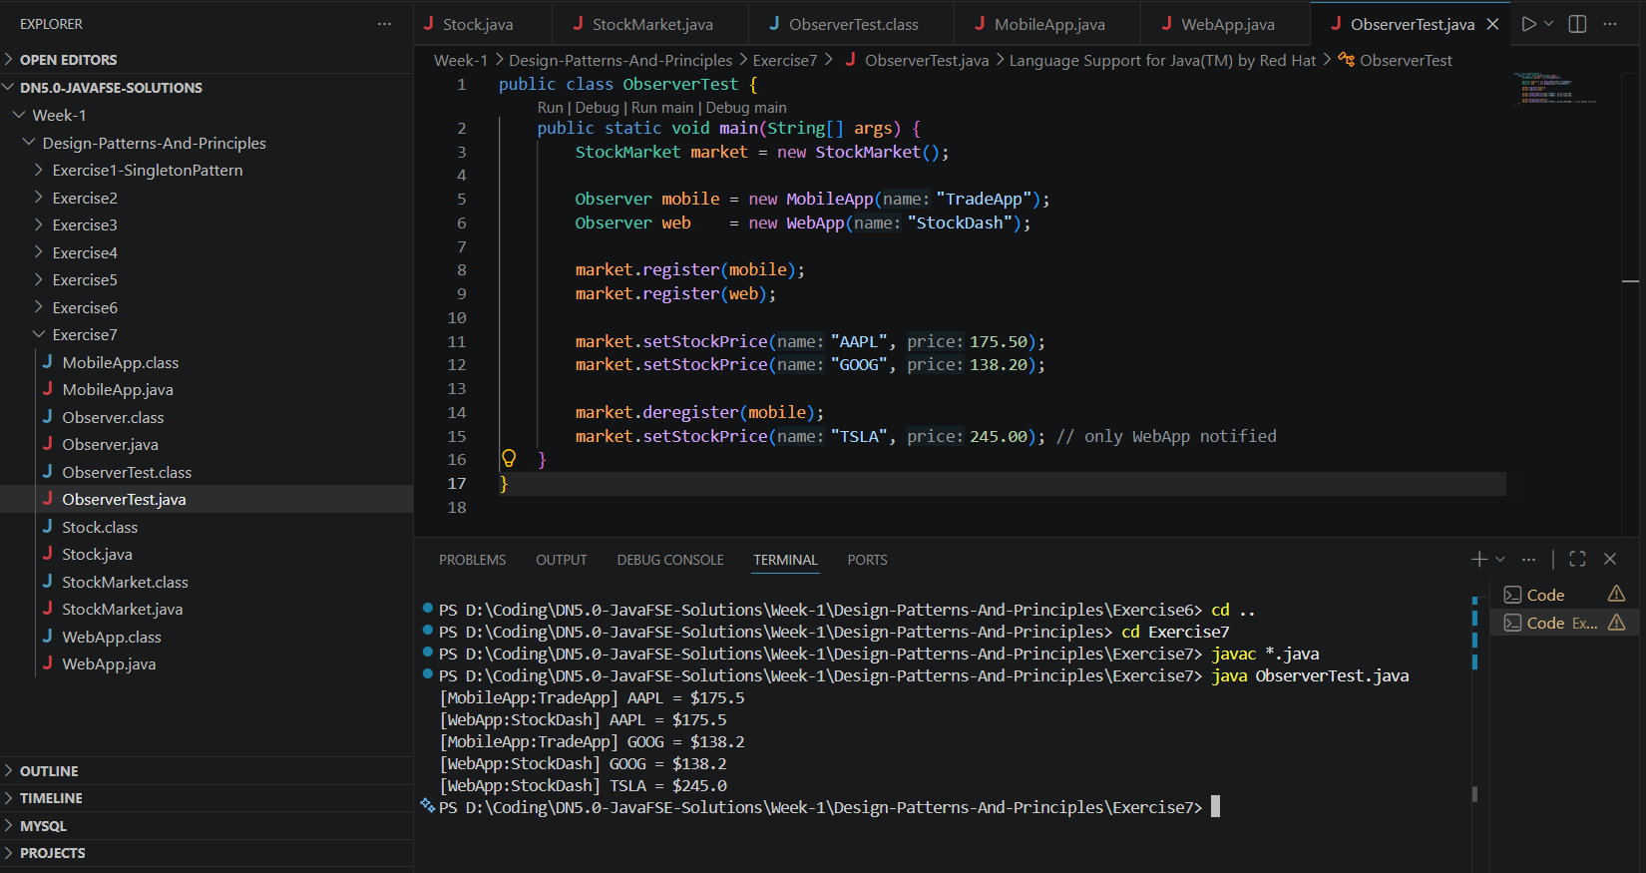

Exercise 8: Implementing the Strategy Pattern

- PaymentStrategy.java
public interface PaymentStrategy {
void pay(double amount);
}

- CreditCardPayment.java
public class CreditCardPayment implements PaymentStrategy {
private final String cardNumber;
public CreditCardPayment(String cardNumber) { this.cardNumber = cardNumber; }

@Override
public void pay(double amount) {
System.out.printf("Paid $%.2f via Credit Card ending %s%n",
amount, cardNumber.substring(cardNumber.length() - 4));
}
}

- PayPalPayment.java
public class PayPalPayment implements PaymentStrategy {
private final String email;
public PayPalPayment(String email) { this.email = email; }

@Override
public void pay(double amount) {
System.out.printf("Paid $%.2f via PayPal account: %s%n", amount, email);
}
}

- PaymentContext.java
public class PaymentContext {
private PaymentStrategy strategy;

public void setStrategy(PaymentStrategy strategy) { this.strategy = strategy; }

public void executePayment(double amount) {
if (strategy == null) throw new IllegalStateException("No strategy set");
strategy.pay(amount);
}
}

- StrategyTest.java
public class StrategyTest {
public static void main(String[] args) {
PaymentContext ctx = new PaymentContext();

ctx.setStrategy(new CreditCardPayment("4111111111111234"));
ctx.executePayment(99.99);

ctx.setStrategy(new PayPalPayment("user@example.com"));
ctx.executePayment(49.50);
}
}

Folder Structure:
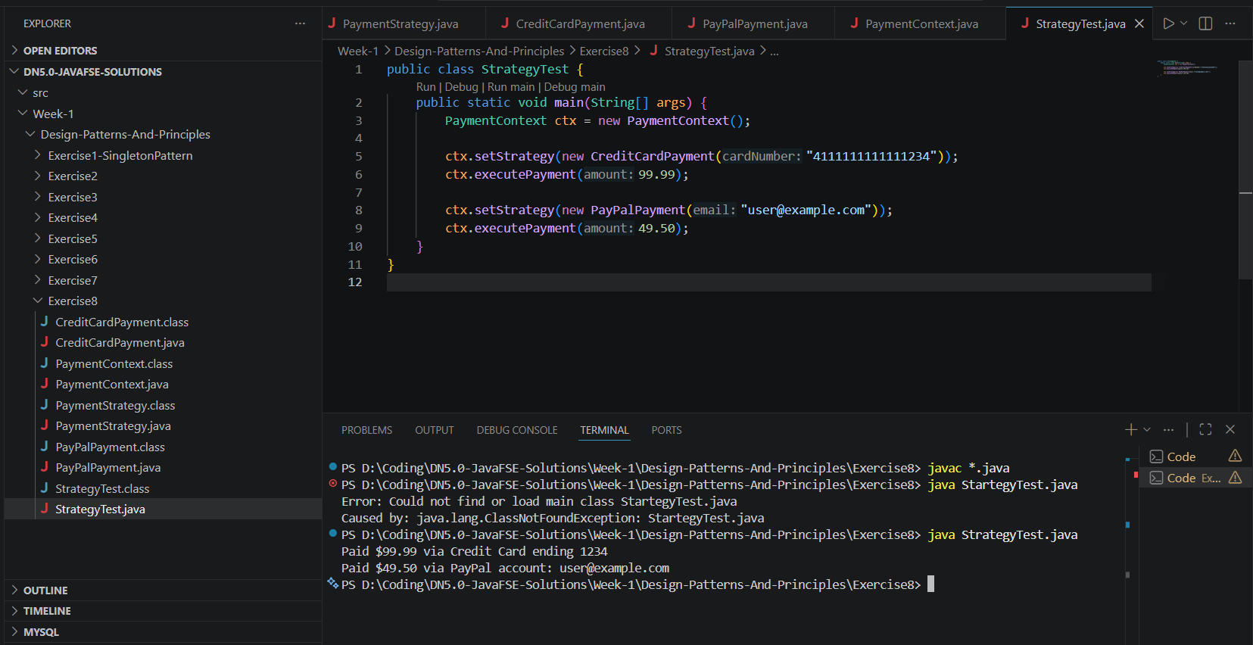

Exercise 9: Implementing the Command Pattern

- Command.java
public interface Command {
void execute();
}

- Light.java
public class Light {
private final String location;
public Light(String location) { this.location = location; }

public void turnOn() { System.out.println(location + " light is ON"); }
public void turnOff() { System.out.println(location + " light is OFF"); }
}

- LightCommandOn.java
public class LightOnCommand implements Command {
private final Light light;
public LightOnCommand(Light light) { this.light = light; }

@Override
public void execute() { light.turnOn(); }
}

- LightCommandOff.java
public class LightOffCommand implements Command {
private final Light light;
public LightOffCommand(Light light) { this.light = light; }

@Override
public void execute() { light.turnOff(); }
}

- RemoteControl.java
public class RemoteControl {
private Command command;

public void setCommand(Command command) { this.command = command; }

public void pressButton() {
if (command != null) command.execute();
}
}

- CommandTest.java
public class CommandTest {
public static void main(String[] args) {
Light living = new Light("Living Room");
Light bedroom = new Light("Bedroom");

RemoteControl remote = new RemoteControl();

remote.setCommand(new LightOnCommand(living));
remote.pressButton();

remote.setCommand(new LightOffCommand(living));
remote.pressButton();

remote.setCommand(new LightOnCommand(bedroom));
remote.pressButton();
}
}

Folder Structure:
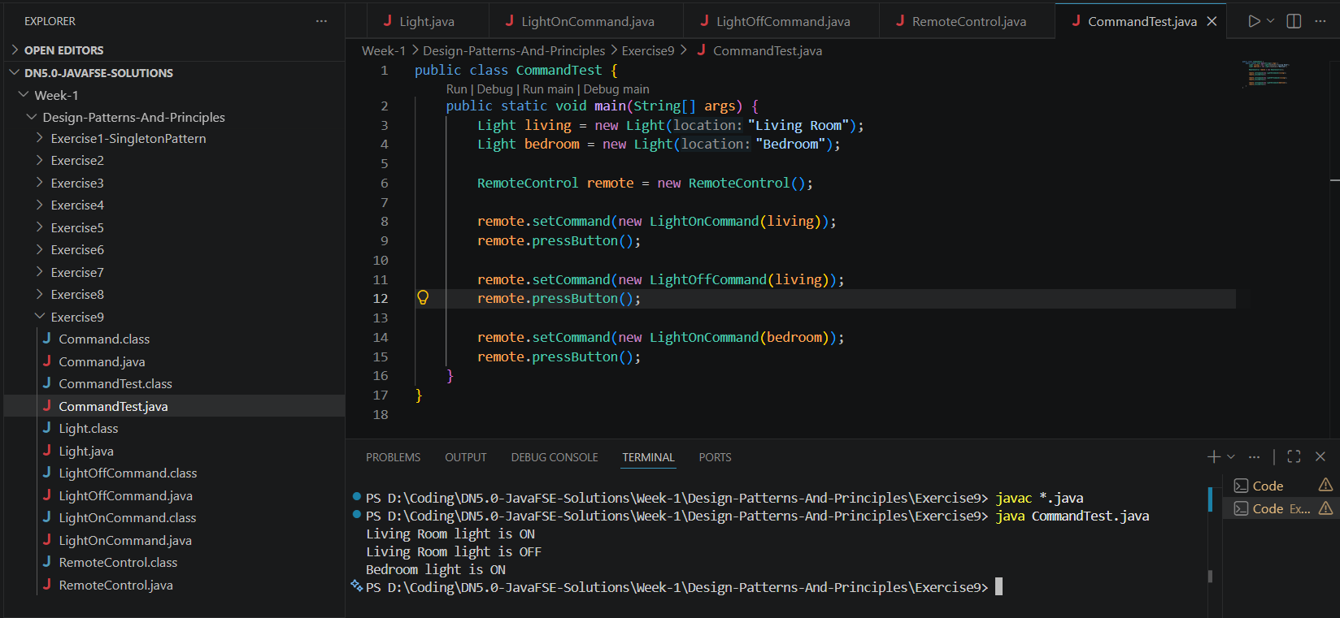

Exercise 10: Implementing the MVC Pattern

- Student.java
public class Student {
private String name;
private String id;
private String grade;

public Student(String name, String id, String grade) {
this.name = name; this.id = id; this.grade = grade;
}

public String getName() { return name; }
public void setName(String name) { this.name = name; }
public String getId() { return id; }
public void setId(String id) { this.id = id; }
public String getGrade() { return grade; }
public void setGrade(String grade){ this.grade = grade; }
}

- StudentView.java
public class StudentView {
public void displayStudentDetails(String name, String id, String grade) {
System.out.println("=== Student Details ===");
System.out.println("Name : " + name);
System.out.println("ID : " + id);
System.out.println("Grade : " + grade);
}
}

- StudentController.java
public class StudentController {
private final Student model;
private final StudentView view;

public StudentController(Student model, StudentView view) {
this.model = model; this.view = view;
}

public void setStudentName(String name) { model.setName(name); }
public void setStudentGrade(String grade) { model.setGrade(grade); }
public String getStudentName() { return model.getName(); }

public void updateView() {
view.displayStudentDetails(model.getName(), model.getId(), model.getGrade());
}
}

- MVCTest.java
public class MVCTest {
public static void main(String[] args) {
Student model = new Student("Alice", "S001", "A");
StudentView view = new StudentView();
StudentController controller = new StudentController(model, view);

controller.updateView();

System.out.println("\nUpdating grade to A+...");
controller.setStudentGrade("A+");
controller.updateView();
}
}

Folder Structure:
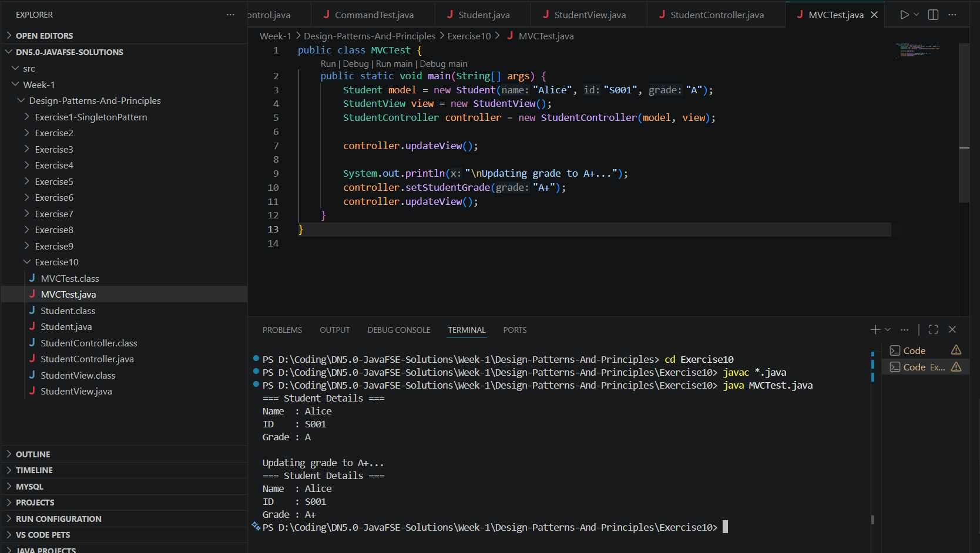

Exercise 11: Implementing Dependency Injection

- Customer.java
public class Customer {
private final int id;
private final String name;

public Customer(int id, String name) { this.id = id; this.name = name; }

public int getId() { return id; }
public String getName() { return name; }

@Override
public String toString() { return "Customer{id=" + id + ", name='" + name + "'}"; }
}

- CustomerRepository.java
public interface CustomerRepository {
Customer findCustomerById(int id);
}

- CustomerRepositoryImpl.java
public class CustomerRepositoryImpl implements CustomerRepository {
private final Map<Integer, Customer> db = new HashMap<>();

public CustomerRepositoryImpl() {
db.put(1, new Customer(1, "Alice"));
db.put(2, new Customer(2, "Bob"));
db.put(3, new Customer(3, "Charlie"));
}

@Override
public Customer findCustomerById(int id) {
return db.getOrDefault(id, null);
}
}

- CustomerService.java
public class CustomerService {
private final CustomerRepository repository; // dependency injected

public CustomerService(CustomerRepository repository) {
this.repository = repository;
}

public Customer getCustomer(int id) {
Customer c = repository.findCustomerById(id);
if (c == null) System.out.println("Customer not found for id: " + id);
return c;
}
}

- DITest.java
public class DITest {
public static void main(String[] args) {
// Wire dependencies manually (poor-man's DI container)
CustomerRepository repo = new CustomerRepositoryImpl();
CustomerService service = new CustomerService(repo); // inject

System.out.println(service.getCustomer(1));
System.out.println(service.getCustomer(3));
service.getCustomer(99); // not found
}
}

Folder Structure:
